Analysis and forecast of Bonston Bluebikes sharing

Student Names: Minjie XU

Executive Summary:
This case study mainly sheds light on hourly bike usage flow analysis and prediction (departure flow). The Bluebikes dataset used in this project comes from Bluebikes website and the weather dataset was scrapped from Weather underground website. During data exploration analysis, we manually aggregated on day, month, weekday, hour to see the bike flow pattern. We analyzed and visualized the busiest station at the busiest moment.
The variables are related to two features: variables hours, week of day, month, season, holiday are related to time and date; variables temperature, humidity, windspeed, pressure, precipitation, weather condition are related to weather. Among them, hours, week of day, month, season, holiday and weather condition are categorical variables, while temperature, humidity, windspeed, pressure, precipitation are numerical variables. For all the categorical variables except weather condition, we used one-hot encoding to make them binary. Then we binned similar weather conditions together into 4 levels principally according to visibility, precipitation. Among numerical variables, we found wind speed are right skewed and the precipitation have a mass of 0 in it. Therefore, we logarithm transformed the former and bin precipitation into two level: 0 means no precipitation and 1 means with precipitation. The dependent variables customers hourly count and subscriber hourly count are right skewed therefore we applied logarithm transformation.
We used time series STL and TBATS, random forest regressor, SVM regressor and combination methods to do respectively the forecast of hourly bike depart flow of subscriber and customer. The combination methods consist of machine learning algorithms like random forest and SVM and trend forecast. By using time series decomposition functions and forecast functions (ARIMA), we could extract and forecast the trend of bike usage. After having the seasonality result from the machine learning model, we added the forecasted trend data back to have a complete prediction result.
In our project, for customer subgroup and subscriber subgroup, respectively, we took 4 weeks hourly data to predict hourly bike flow in 2 subsequent days. The whole period to be analyzed is from 2017-01-01 00:00 to 2019-3-21 23:00, therefore, 27 segments in total for each user type subgroup. Among them, the 1st ~10th segments were used as training data to turn parameters and the 11th ~27th segments were used as validation data to compare model performance. And we also used varImpPlot() function to know which were the most important features.
During the process, we used 10-fold cross validation to turn parameters of models and comparing the mean RMSE to select the best model set. The results show STL is more adapted to predict subscribers’ bike flow while combination method of random forest and trend forecast is more suitable to predict customers’ bike flow. That also shows casual bike users are more sensitive to weather.

I. Background and Introduction
Bluebikes is Metro Boston’s public bike share program, with more than 1800 bikes at over 200 stations across Boston and nearby areas. The bikes sharing program launched in 2011. The program aimed for individuals to use it for short-term basis for a price. It allows individuals to borrow a bike from a dock station then return it after using, which makes it ideal for one-way trips.
The City of Boston is committed to providing bike share as a part of the public transportation system. However, to build a transport system that encourages bicycling, it is important to build knowledge about the current bicycle flows, and what factors are involved in the decision-making of potential bicyclists when choosing whether to use the bicycle. It is logical to make hypotheses that age and gender, bicycle infrastructure, safety perception are possible determinants of bicycling. On the short-term perspective, it has been shown that weather plays an important role whether to choose the bicycle.
The aims of the project were to investigate how busy each station is and to analyze the division of bicycle trip directions and trip duration departing from/return to a busy station, as well as the mean flows variation within a day or during the period.
It also aimed to gain insight of the factors that could give short-term perspective of bicycle flows in Boston. The addition to the factors (time, date and weather) included in the regression model, there also exist other factors that influence how the bicycle flows vary over longer periods time. For example, general tendency to use the bicycle. Therefore, there is potential to improve the regression model accuracy by incorporating a long-term trend estimate taken over the time series of bicycle usage. Then the result from the machine learning algorithm-based regression model were compared with the time series forecasting-based models.

II. Data Exploration and Visualization
The Bluebikes collects and provides system data to the public. The datasets used in the project can be download through this link (https://www.bluebikes.com/system-data). Based on this time series dataset (start from 2017-01-01 00:00:00 to 2019-03-31 23:00:00), we could have the information includes: Trip duration, start time and data, stop time and data, start station name and id, end station name and id, bike id, user type (casual or subscribed), birth year, gender. Besides, any trips that were below 60 seconds in length is considered as potentially false starts, which is already removed in the datasets. We did not use gender and birth year columns. There was no NA for this dataset, all hours with no data should be assign 0, since there was actually no bike sharing.
The hourly weather data, from 2017-01-01 00:00:00 to 2019-03-31 23:00:00, used in the project was scrapped using python selenium from Logan airport station (42.38 °N, 71.04 °W), maintained by weather underground website, webpage (https://www.wunderground.com/history/daily/us/ma/boston/KBOS/date/2019-7-15). The hourly weather observations included time, temperature, dew point, humidity, wind, wind speed, wind gust, pressure, precipitation, precipitation accumulated, condition.
After analyzing correlation among weather variables, we found temperature and dew point had strong correlation 0.907 (see figure 1). Here we simply dropped the dew point variable, since temperature is more meaningful for our model.
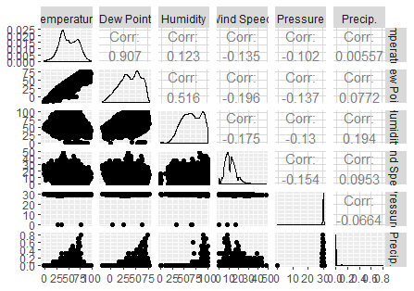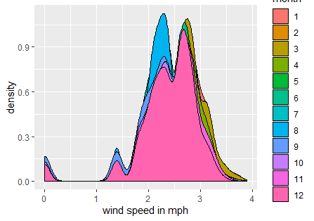
Figure 1 correlation plots and matrix of weather features Figure 2 density plot of wind of each month
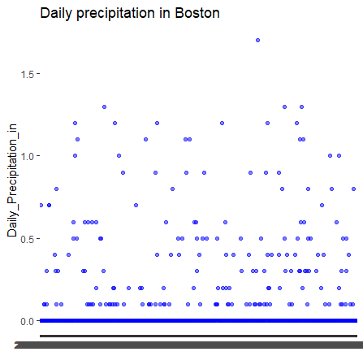
Figure 3 Word cloud for weather condition Figure 4 Precipitation (inches) as a function of date

For the weather condition variable, we used world cloud to have a basic idea about weather condition of Boston. In this word cloud, the bigger the term is, the larger percentage of the contributing factor is in weather condition description. As figure 3 shows, the top 3 contributing factors are ‘cloudy’, ‘fair’, ‘windy’ and ‘rain’. We could conclude that most weather in Boston were cloudy and fair, even if there would also be many windy and rainy days. And that corresponded to the depiction of figure 2 and 4.

Now, we would like to have a basic idea about the bike flow pattern. We split the count of bike usage into subscriber and customer subgroups, since they have different characteristics. During data exploration analysis, we manually aggregated on day, month, weekday, hour to see the bike flow pattern. To better visualize the overall time series, we used stacked barchart to present the year-month aggregate time series of each user type subgroup, since it could compare subgroup values and gave us a clear picture of which subtotal contributes the most to an overall sum. We used multiple line plot for daily bike usage of each user type subgroup to see the difference in quantity and their tendency. The figure 5 shows the bike were mainly used by the subscriber, while on some days, customers used more bikes than subscribers (see multiple line plot of figure 5). The count of bike usage of both subscribers and customers are seasonally distributed with visually trend.

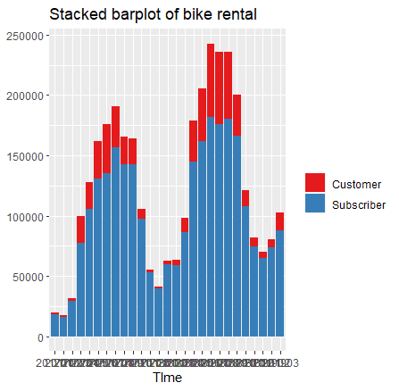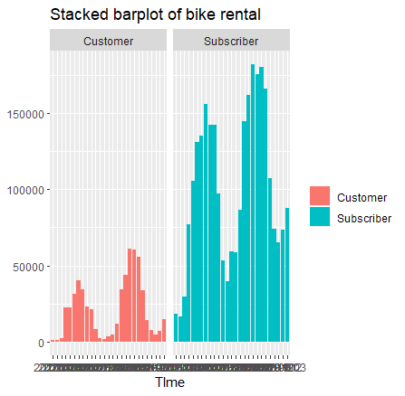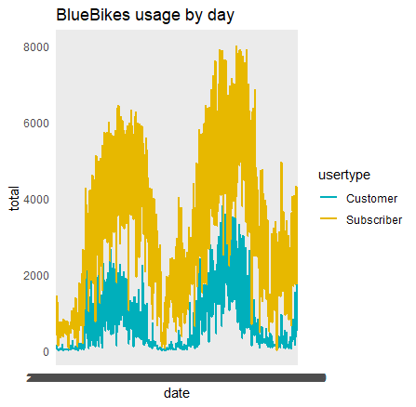
Figure 5 stacked barchart, faceting barchart and multiple line plot of bike usage

Then the bike flow could be analyzed with respect of hour and weekday. Figure 6 shows subscribers’ usage has clear peak time around 8~9 am and 5~6 pm while the customer use bike more in the afternoon. The outliers in the middle plot probably can be explained that there were some casual group cycling events. Figure 7 shows subscribers’ usage were mainly in weekdays while there were many customers’ usage on the weekend.

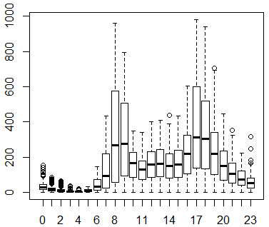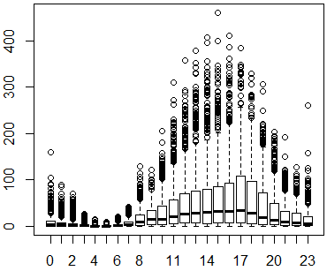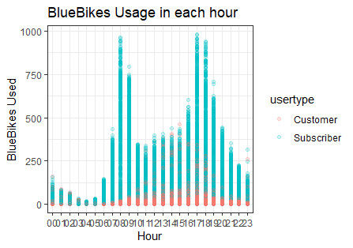
Figure 6 boxplots of subscriber-left and customer-middle and scatterplot of bike usage versus hour

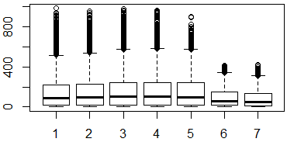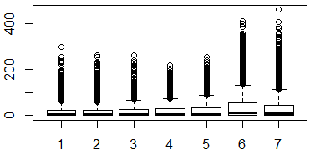
Figure 7 boxplots of subscriber-left and customer-right bike usage versus weekdays (6-Saturday, 7-Sunday)

Next, we would like to find out the busiest station at the peak time of the busiest day. The heatmaps in Figure 8 are created under “leaflet” package and the busiest station is marked on the map. The busiest day is 2018-09-14 and peak time of that day is 6~7 pm for departing bike flow and 5~6 pm for returning bike. The busiest depart and return stations are respectively the "MIT Stata Center at Vassar St / Main St" and "Nashua Street at Red Auerbach Way". Figure 9 shows the comparison of bike flow among stations at that moment.

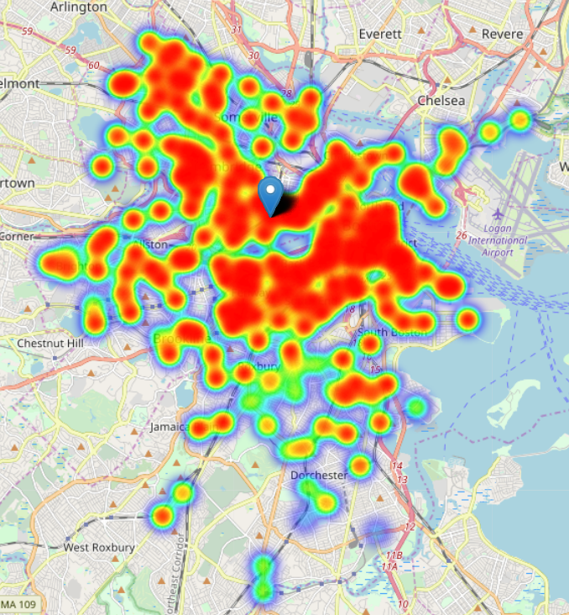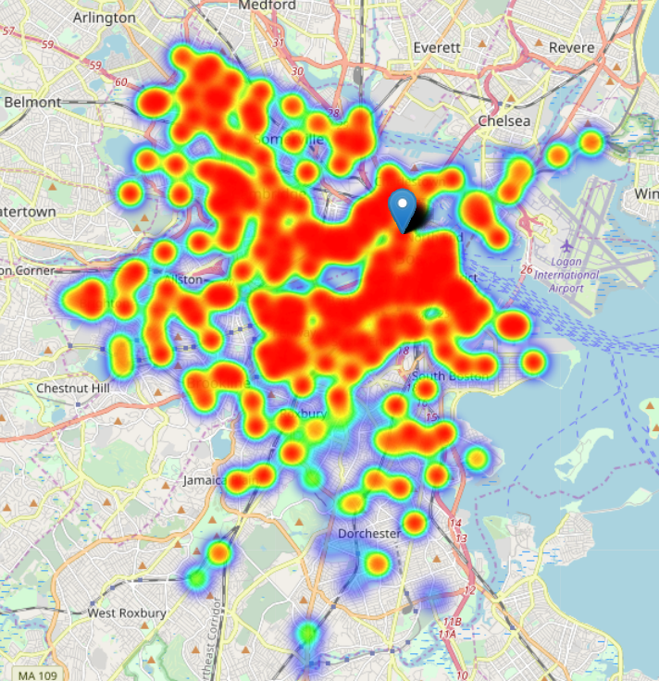
Figure 8 busy degree of each depart stations-left and return stations-right at the peak time of the busiest day

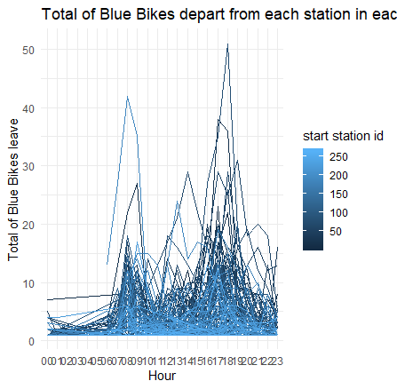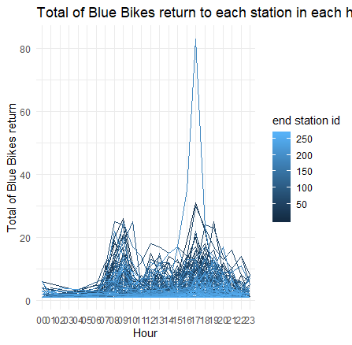
Figure 9 comparison of bike flow among stations at the busiest moment (depart-left, return-right)

We were also curious about the duration of bike sharing trip also the directions. After removing the outliers, we obtained the density plot of duration overall. And their orientations divided by towards directions are shown in figure 10. Most trips were short than 10 min and many trips were towards to southeast.

Then we came back to the busiest moment. The bike usage count and the bike trip duration chart for both depart and return condition were shown in figure 11.
Let’s put the bottom row of figure 11 on the right heatmap of figure 8 and unfold the busiest return station "Nashua Street at Red Auerbach Way" with details. We found that people returned bikes mainly from financial district in southeast to north station. It was also found that many people returned bikes from backbay direction and the average commute time was about 17 min, which shows the lack of other public transportation options in that region.
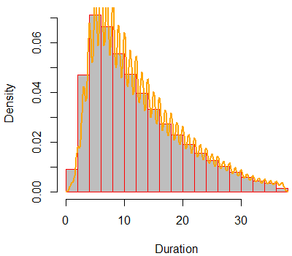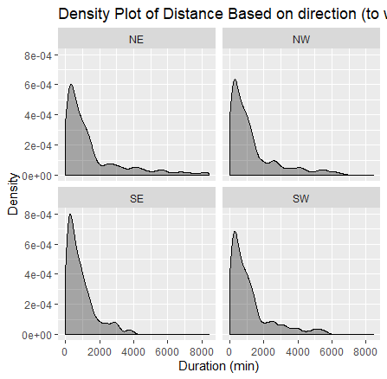
Figure 10 density plots of bike sharing duration

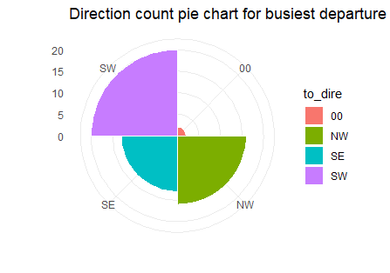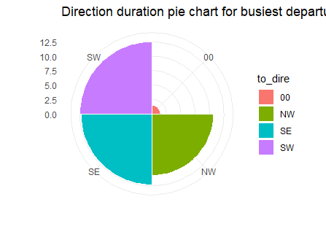
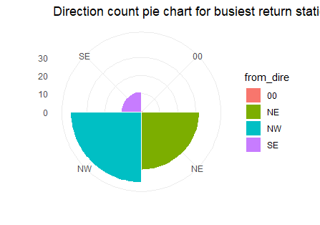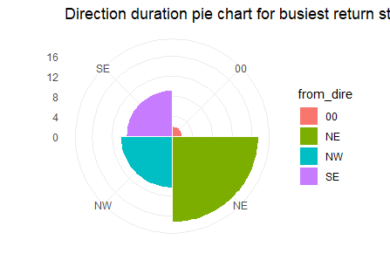
Figure 11 bike usage count and duration of each divided duration of the busiest station (depart-top, return-bottom) at the busiest moment

III. Data Preparation and Preprocessing
The weather dataset had some minor errors that some pressure values were 0. We replaced them by NA. Then we found out 1317 NA versus 137739 values related to weather. Therefore, the miss value rate was 0.96%. We used interpolation to fill up the missing values. Then we merged the weather dataset and bike usage dataset based on same date and time.
The variables are related to two features: variables hours, week of day, month, season and holiday are related to time and date; variables temperature, humidity, windspeed, pressure, precipitation, weather condition are related to weather. Among them, hours, week of day, month, season, holiday and weather condition are categorical variables, while temperature, humidity, windspeed, pressure, precipitation are numerical variables. The dependent variables customers hourly count and subscriber hourly count were right skewed. Therefore, we needed to apply logarithm transformation.
Table 1 summary table for time and date related variables
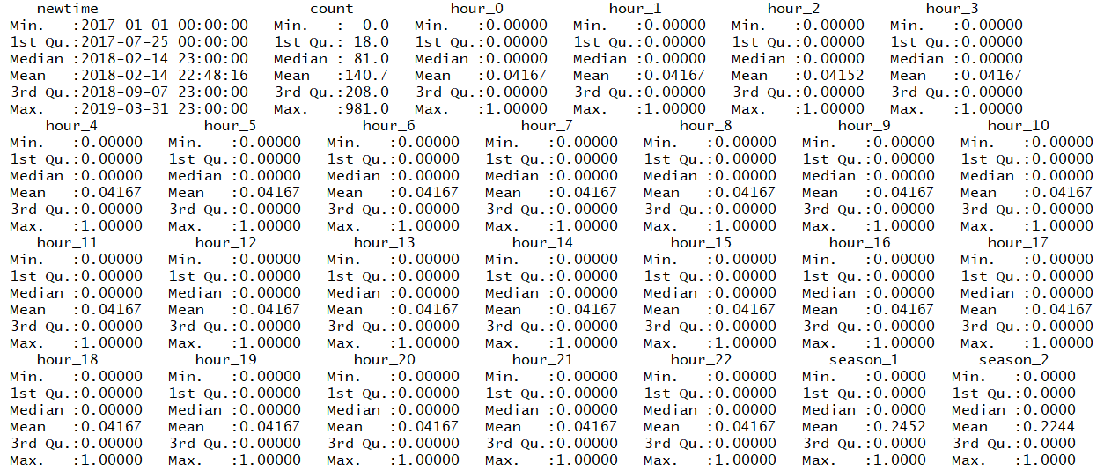
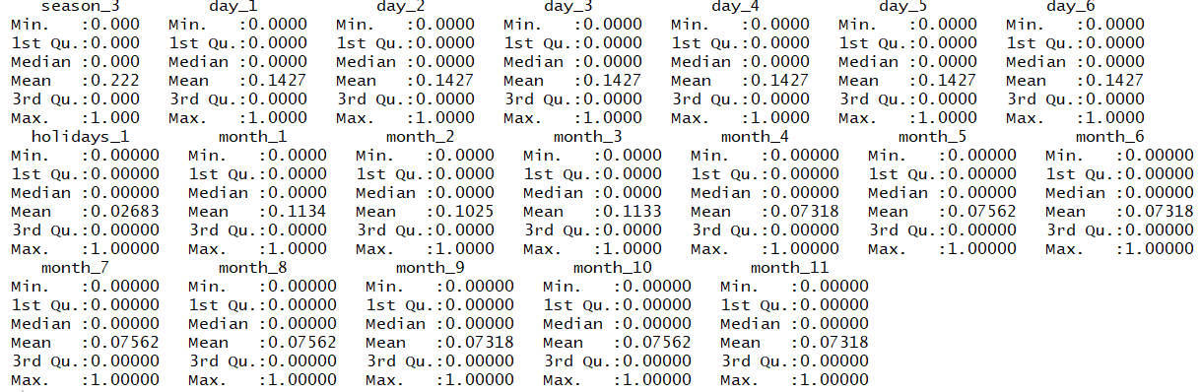

Table 2 summary table for weather related variables
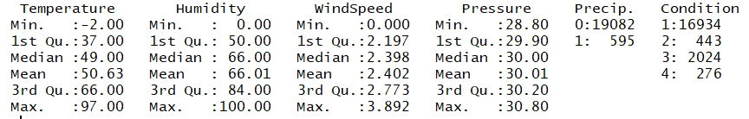
Among numerical variables, we found wind speed were right skewed and the precipitation had a mass of 0 in it (see figure 4). Therefore, we logarithm transformed the former and binned precipitation into two level: 0 means no precipitation and 1 means with precipitation. For all the categorical variables except weather condition, we used one-hot encoding to make them binary. For weather condition, we binned similar conditions together into 4 levels principally according to visibility, precipitation. For example, we assigned cloudy, mostly cloudy, fair etc. value 1, assigned fog, haze, smoke etc. value 2, assigned light rain, light snow, small hail etc. value 3 and assigned snow, thunderstorm, wintry mix-windy etc. value 4. Data summary table after data preparation and preprocessing is shown in table 1 and 2.
Correlation matrix and plots are shown in figure 1. Here we did not use PCA since our categorical variables are too sparse and correlation among numerical variables are not strong.
Our target was to make prediction of departed bikes (or returned bikes) for the next one or two hours. Therefore, an ideal model is the one can be explained clearly, needs less time to train and gives relatively accurate predictions. Here we took 4 weeks hourly data to predict the subsequent 2 days’ hourly bike departure flow. Because 4 weeks contains 4 complete seasons for time series forecast, and the weather, the geographic info would not have big change, which is good for the forecast model. The whole period to be analyzed is from 2017-01-01 00:00 to 2019-3-21 23:00. Therefore, there are 27 segments in total for each user type subgroup. Among them, the 1st ~10th segments are used as validation data, used to turn parameters of models. The 11th ~27th segments are used as test data to compare model performance based on mean RMSE.

IV. Data Mining Techniques and Implementation
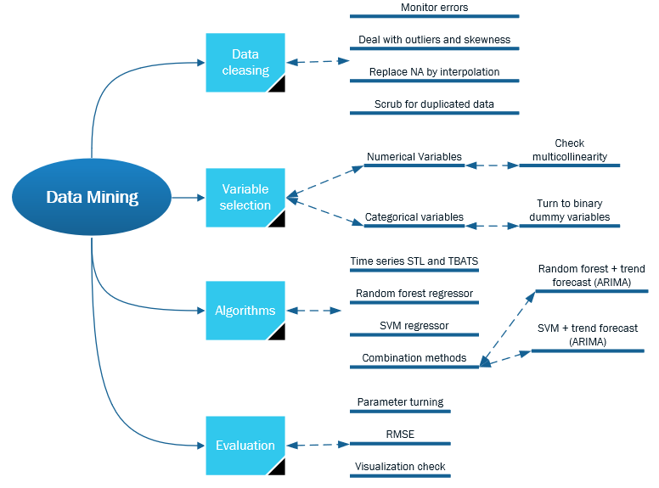
The hourly bike sharing count are typical time series dataset. In this project, we would like to use STL (Seasonal and Trend decomposition using Loess), TBATS (Trigonometric Seasonal, Box-Cox Transformation, ARMA residuals, Trend and Seasonality), random forest regressor, SVM regressor and combination method to do forecast of hourly bike flow. Calculating speed, accuracy and interpretability were the reasons that we selected these prediction models.
For easier understanding and better illustrating, the plots and predictions we used below came from a randomly selected segment from validation dataset, which was using 2018-9-23 00:00 ~ 2018-10-20 23:00 to predict hourly bike usage between 10-21 00:00 and 10-22 23:00.
a) Time series methods
Time series dataset only took two columns: time and count. By STL, we used mstl() function to decompose hourly bike usage flow into multi-seasonality(day and week), trend and noise. Then we used stlf() function to make forecast. Similarly, by TBATS, we used tbats() function to decompose and used forecast() to forecast the next 48 hours.
TBATS were slower than STL model, and they have same RMSE of 5.56853 for subscriber and 4.081881 for customer. The decomposition plot and forecast plot are shown in figure 13 and 14.
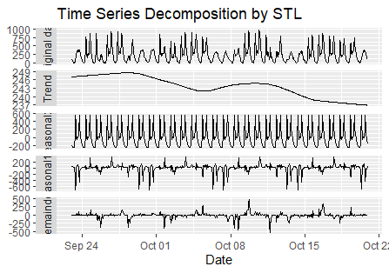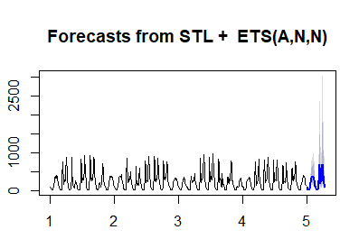
Figure 13 prediction results from STL model for subscriber
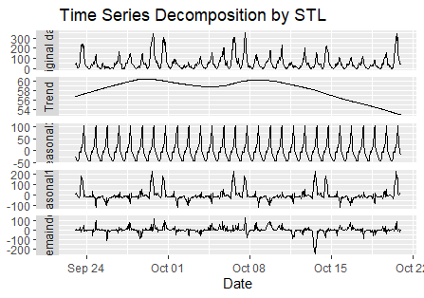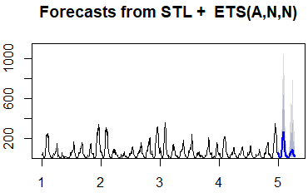
Figure 14 prediction results from STL model for customer
b) random forest
The input dataset has 50 variables. The parameters (mtry and ntree) of random forest regression model were determined by best RMSE score of 10-fold cross validation of training dataset (1st ~10th segments).
ntree: number of trees. Enough trees can stabalize the error but using too many trees is unnecessarily inefficient, especially when using large data sets.
mtry: the number of variables to randomly sample as candidates at each split. When mtry =p the model equates to bagging. When mtry =1 the split variable is completely random, so all variables get a chance but can lead to overly biased results.
RMSE was used to select the optimal model using the smallest value. The final values used for the subscriber model were mtry = 31 and ntree = 1000, while that for the customer model were mtry = 28 and ntree = 100.
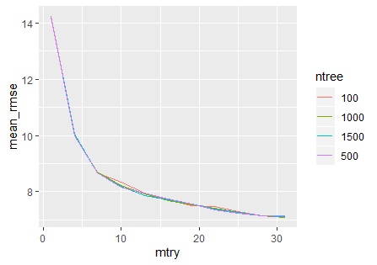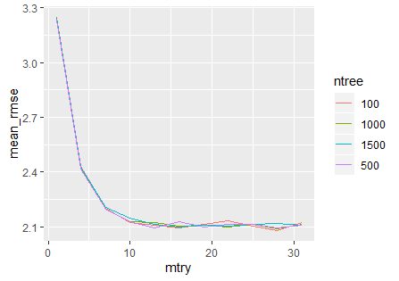
Figure 15 Turning parameters results of random forest for subscriber-left and customer-right
This random forest model has a RMSE of 10.51069 for subscriber and 2.707978 for customer. Then we used varImpPlot() function to know which were the most important features. And figure 16 and 18 show examples of tree respectively for subscriber and customer model.
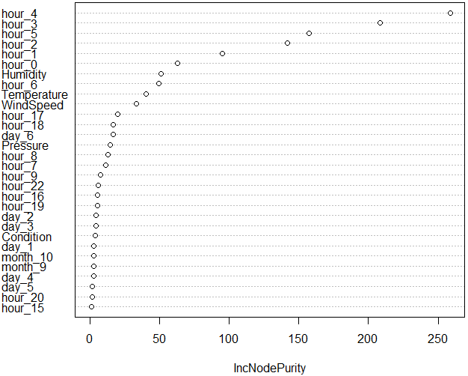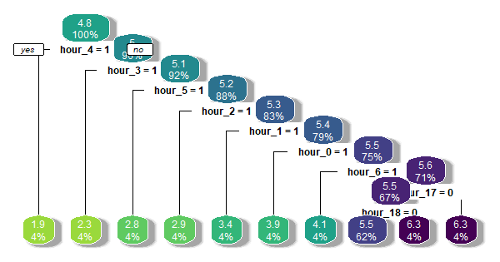
Figure 16 variable importance for subscriber model Figure 17 a tree for subscriber model
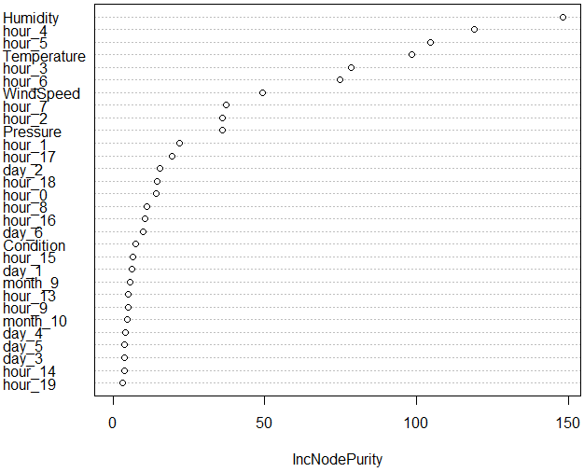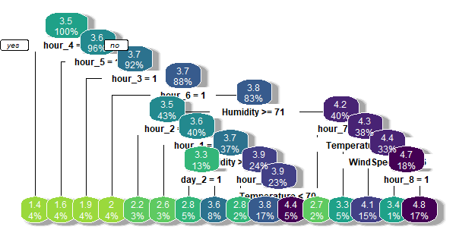
Figure 18 variable importance for customer model Figure 19 a tree for customer model
c) SVM
We scaled dataset for SVM regressor since this algorithm tend to individualize the hyperplane which maximizes the margin. The parameters (epsilon and cost) of SVM regression model were determined by best RMSE score of 10-fold cross validation of training dataset (1st ~10th segments).
epsilon: the value of epsilon defines a margin of tolerance where no penalty is given to errors. The larger epsilon is, the larger errors you admit in your solution.
Cost: parameter to avoid overfitting.
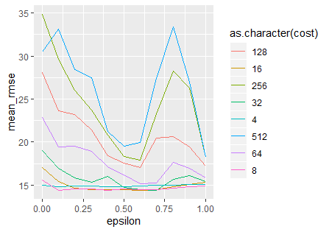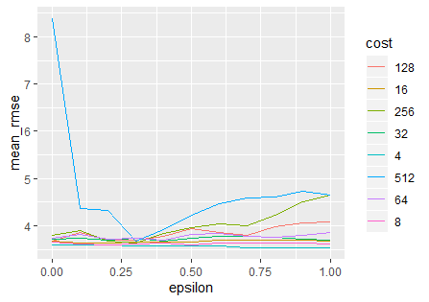
Figure 20 Turning parameters results of SVM for subscriber-left and customer-right
RMSE was used to select the optimal model using the smallest value. The final values used for the subscriber model were epsilon = 0.1 and cost = 8, while that for the customer model were epsilon = 0.8 and cost = 4.
This SVM model has a RMSE of 11.37712 for subscriber and 2.852751 for customer.
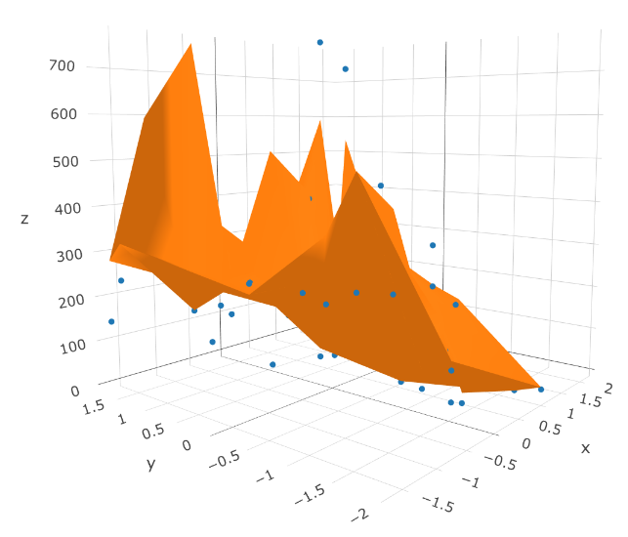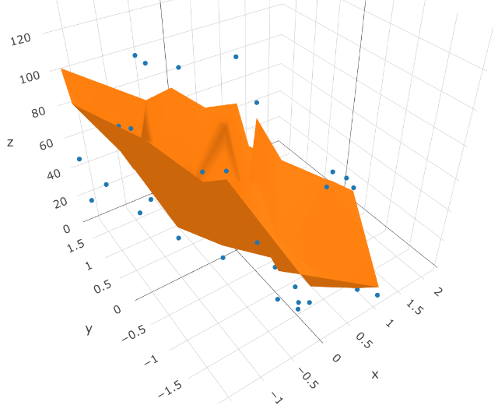
Figure 21 3D plot of SVM regression prediction versus humidity-x and temperature-y for subscriber-left and customer-right
d) combination method
Our time series dataset has multi-seasonality and is univariate. By using time series decomposition functions and forecast functions (ARIMA), we could extract and forecast the trend of bike usage. We emphasized on the importance to generate trend curve estimates that do not follow the seasonal variations: the seasonal variations should be captured explicitly by the input weather related variables in the random forest regression model. After having the seasonality result from the random forest model, we added the forecasted trend data back to have a complete prediction result.
Figure 22 and 23 show the result predicted by ARIMA for subscriber and customer. The variance importance plots of random forest on trend-extracted data are shown in figure 24 and 26. We found that the customers’ model importance of weather-related variables ranked farther ahead than that of the subscribers. Their tree example plots are given in figure 25 and 27.

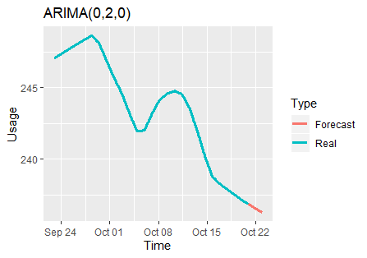
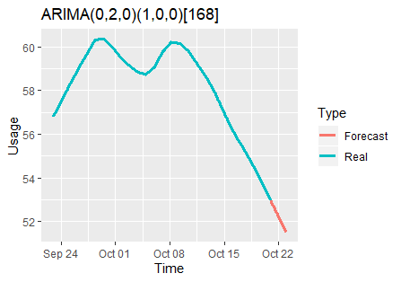
Figure 22 trend forecast of subscriber by ARIMA Figure 23 trend forecast of customer by ARIMA

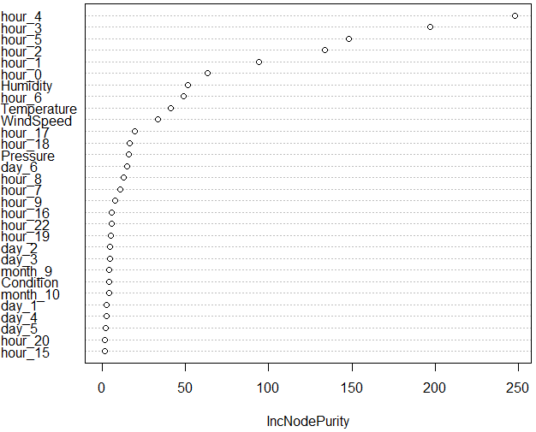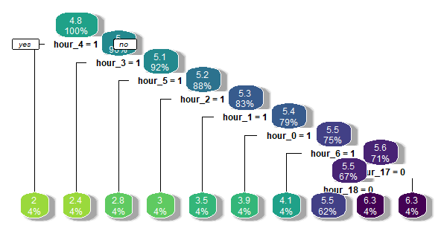
Figure 24 variable importance for subscriber model Figure 25 a tree for subscriber model

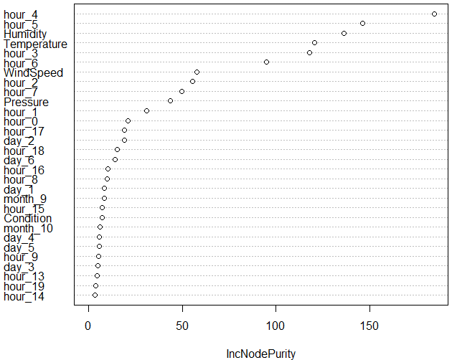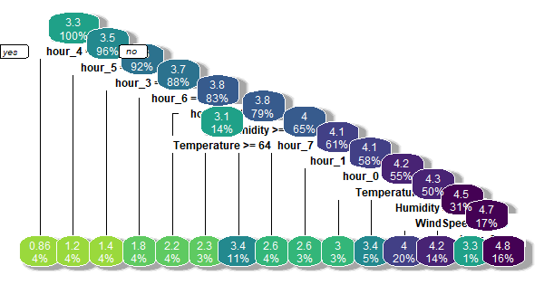
Figure 26 variable importance for customer model Figure 27 a tree for customer model

The model combines random forest and trend forecast has a RMSE of 11.48264 for subscriber and 2.852751 for customer. The model combines SVM and trend forecast has a RMSE of 10.95582 for subscriber and 2.557671 for customer.

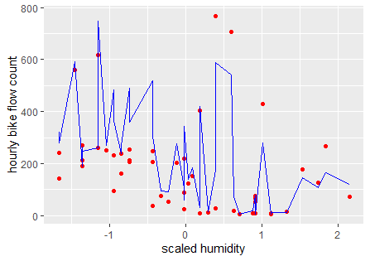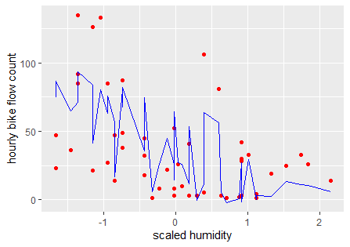
Figure 28 SVM regression with trend forecast prediction versus scaled humidity for subscriber-left and customer-right
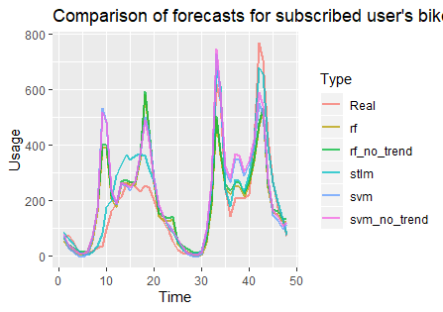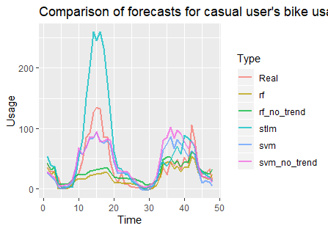
Figure 29 comparison of forecasts for subscriber Figure 30 comparison of forecasts for customer

V. Performance Evaluation
Figure 29 and 30 show the comparation of prediction results of hourly departure bike usage between 10-21 00:00 and 10-22 23:00 from each model.
To evaluate each model’s performance, we will evaluate the mean and standard deviation of RMSE of validation segments (11th ~27th) predictions and comparing the boxplot of these RMSE.
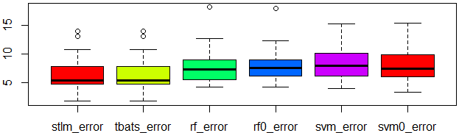
Figure 31 comparison of RMSE of each model for subscriber

Table 3 summary table for RMSE of each model for subscriber
method | STL | TBATS | RF_trend | RF | SVM_trend | SVM
mean RMSE | 6.660810 | 6.660810 | 8.112592 | 8.356178 | 8.537242 | 8.256557
sd RMSE | 3.313171 | 3.313171 | 3.569774 | 3.385721 | 3.383546 | 3.308639

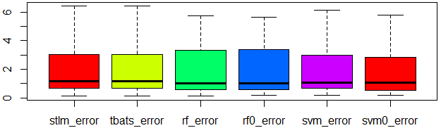
Figure 32 comparison of RMSE of each model for customer

Table 4 summary table for RMSE of each model for customer
method | STL | TBATS | RF_trend | RF | SVM_trend | SVM
mean RMSE | 1.918532 | 1.918532 | 1.895986 | 1.914610 | 2.135314 | 2.052511
sd RMSE | 1.799212 | 1.799212 | 1.705584 | 1.655035 | 2.031287 | 1.946767

The results show STL is more adapted to predict subscribers’ bike flow while combination method of random forest and trend forecast is more suitable to predict customers’ bike flow. That also shows casual bike users are more sensitive to weather.

VI. Discussion and Recommendation
Based on the performance comparation of models, we can conclude that: For subscribers’ bike flow prediction, time series method STL is better, considering calculate speed and mean of RMSE. For customers’ bike flow prediction, random forest with trend forecast is better, which shows customers’ bike usage is more sensitive to weather.

a> Advantages
This approach has compared different machine learning algorithms, time series methods, as well as combination methods. Since time series data cannot be correctly predicted if the prediction period is long, it makes sense to train model on 4 weeks data and to predict the next 48 hours. Both accuracy and computer time are taken into account.

b> Shortcomings
This approach does not consider the effect of other public transportation. For example, if there were some commuter trains or subways cutting service, subscribers would change their normal usage pattern accordingly and customers’ usage could also increase.
In addition, this project just predicted the overall hourly bike departure flow. The bike flow patterns of each station are probably different.

c> Potential improvement
The potential improvement could be applying this approach on the station of interest, then combining the data with nearby public transportation status, and using adapted machine learning algorithm to give prediction of return station. By this way, we could calculate the net bike flow of the station of interest. And the Bluebikes company can plan accordingly and put more bikes or free more docks if they know the station is going to become very busy.

VII. Summary
This case study mainly sheds light on hourly bike usage flow (departure) prediction. The study began by variable section and preprocessing, based on the dataset collected by Bluebikes and Weather underground. We manually aggregated datasets on month, weekday, hour to see the bike flow pattern. We analyzed and visualize the busiest station at the busiest moment.
We used time series STL and TBATS, random forest regressor, SVM regressor and combination methods to do respectively the forecast of hourly bike departure flow of subscriber and customer. During the process, we used 10-fold cross validation to turn parameters of models and compared the mean RMSE to select the best model. The results show STL is more adapted to predict subscribers’ bike flow while combination method of random forest and trend forecast is more suitable to predict customers’ bike flow. That also shows casual bike users are more sensitive to weather.

